Questions from past papers

Past paper question MEI June 15 Core 3 Question 7i
- How to tackle a “show that…” question
- How to use the words in the question to help you
- How to look at the mark allocation as a guide.
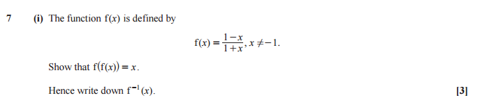

Try the question…

Mark Scheme
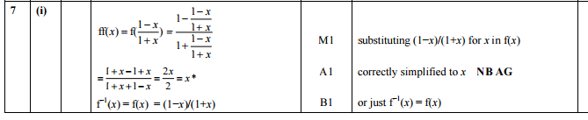

Examiner’s report
7(i) Most candidates gained a method mark for substituting (1-x)/(1+x) for x in f(x). However, the simplification of the ensuing algebraic fraction proved to be problematic to many candidates, who failed to clear the subsidiary denominators correctly. Concluding that f⁻¹(x) = f(x) should of course be a ‘write down’ from ff(x) = x; however, virtually all candidates found f⁻¹(x) by rearranging the formula for x = f(y), usually correctly. Occasionally we were offered f⁻¹(x) = 1/f(x) = (1+x)/(1-x).

Marking exercise 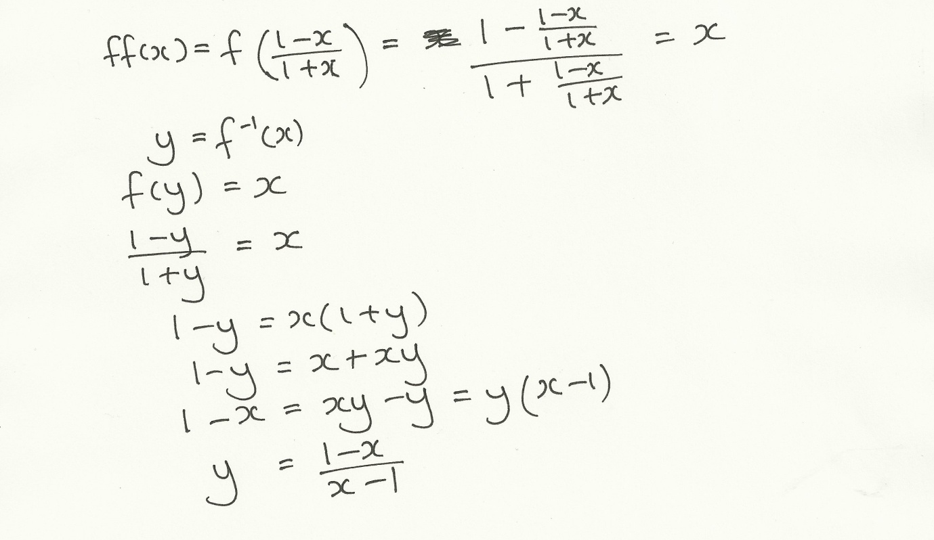

Past paper question Edexcel June 15 Core 4 Question 1
- Starting the paper with a basic question
- Looking at how the answer should be written
- Where are your checking strategies?
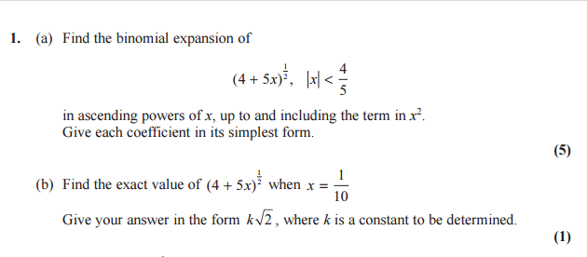

Try the question…

Markscheme
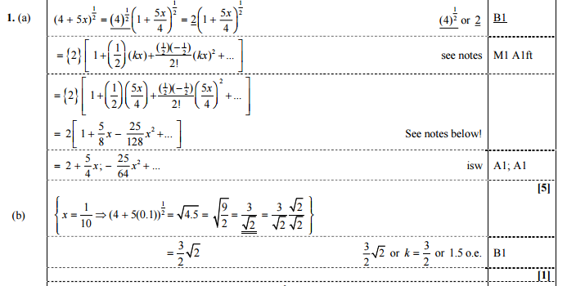
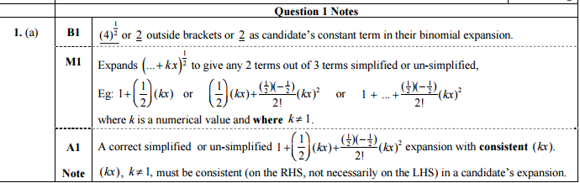
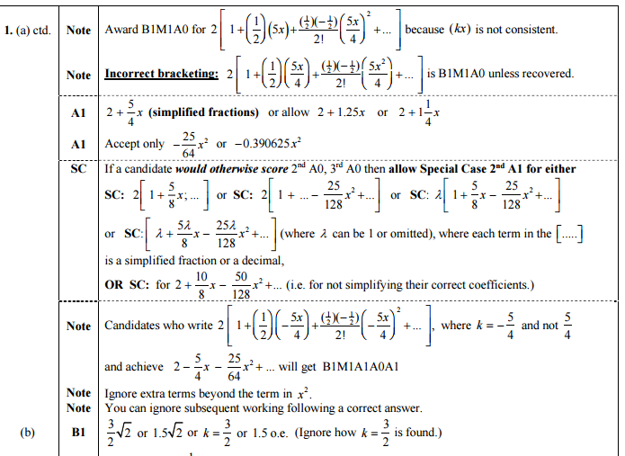

Examiner’s report
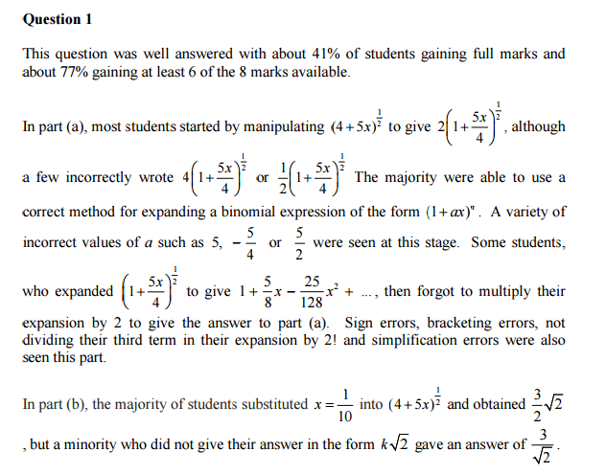

Marking exercise 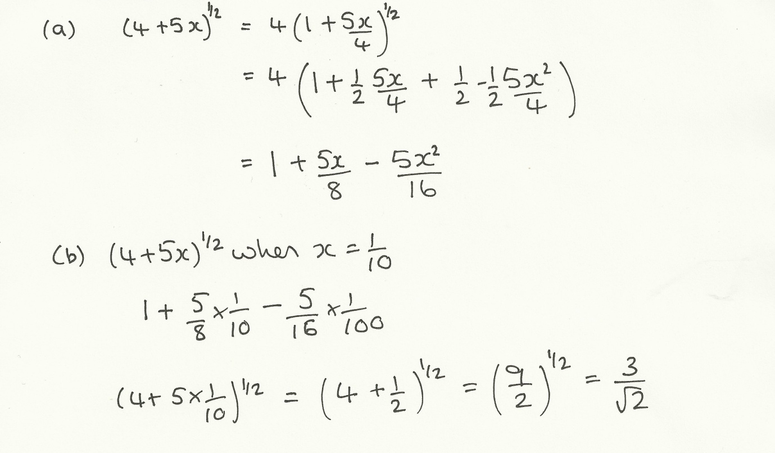

Crossed out work

OCR and MEI
Rules for replaced work
If a candidate attempts a question more than once, and indicates which attempt he/she wishes to be marked, then examiners should do as the candidate requests If there are two or more attempts at a question which have not been crossed out, examiners should mark what appears to be the last (complete) attempt and ignore the others.
NB Follow these maths-specific instructions rather than those in the assessor handbook

Edexcel
Crossed out work should be marked UNLESS the candidate has replaced it with an alternative response.
If a candidate makes more than one attempt at any question:
- If all but one attempt is crossed out, mark the attempt which is NOT crossed out.
- If either all attempts are crossed out or none are crossed out, mark all the attempts and score the highest single attempt.

AQA
Not seen in recent papers but 2005 papers say they average the marks for two attempts (rounded down)

